netflix Database (MySQL)

Create Database
CREATE DATABASE Netflix_Database;
USE Netflix_Database;

Create Table

CREATE TABLE netflix (
show_id VARCHAR(20) PRIMARY KEY,
type VARCHAR(20),
title VARCHAR(255),
director VARCHAR(255),
country VARCHAR(100),
date_added DATE,
release_year INT,
rating VARCHAR(20),
duration VARCHAR(50),
listed_in VARCHAR(255),
Sales INT,
Revenue DECIMAL(12,2),
Profit DECIMAL(12,2),
Views BIGINT,
Subscription_Type VARCHAR(50),
Region VARCHAR(100)
);

Insert data
Like:

INSERT INTO netflix
(show_id, type, title, director, country, date_added, release_year, rating, duration, listed_in, Sales, Revenue, Profit, Views, Subscription_Type, Region)
VALUES
('s1', 'Movie', 'The Great Adventure', 'John Smith', 'United States', '2024-01-15', 2024, 'PG-13', '120 min', 'Action, Adventure', 1200, 450000.00, 125000.00, 3500000, 'Premium', 'North America'),

('s2', 'TV Show', 'Mystery House', 'Emma Wilson', 'India', '2023-08-10', 2023, 'TV-MA', '2 Seasons', 'Drama, Mystery', 980, 320000.00, 85000.00, 2800000, 'Standard', 'Asia'),

('s3', 'Movie', 'Comedy Nights', 'David Lee', 'Canada', '2022-05-20', 2022, 'PG', '95 min', 'Comedy', 760, 210000.00, 60000.00, 1800000, 'Basic', 'North America');

#output
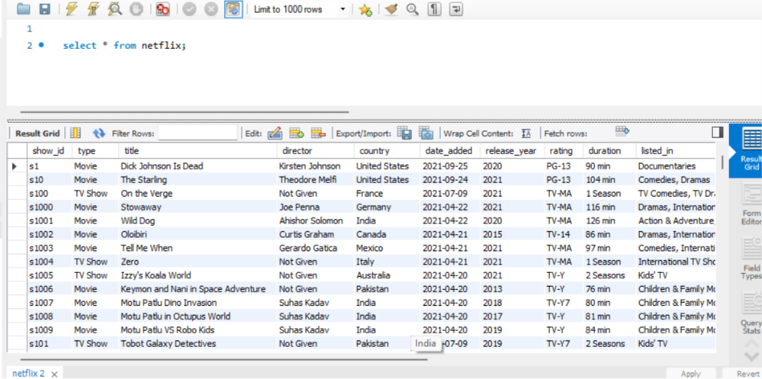

MySQL Queries

Total Records
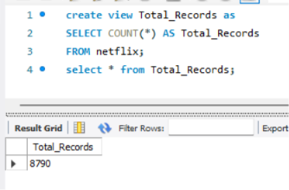

Movies vs TV Shows
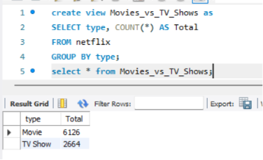

Total Sales
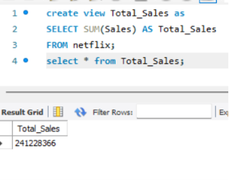

Total Revenue
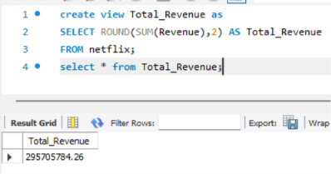

Total Profit
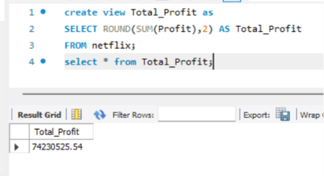

Average Revenue
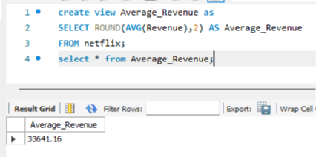

Top 10 Highest Revenue Titles
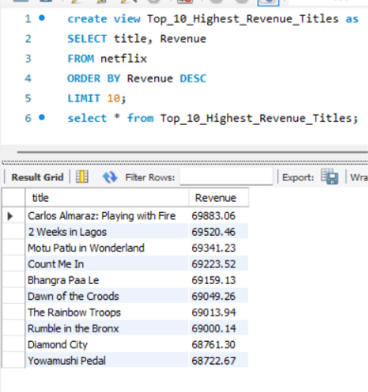

Top 10 Highest Profit Titles
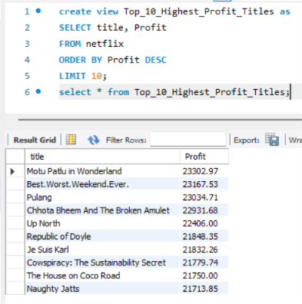

Top 10 Highest Sales
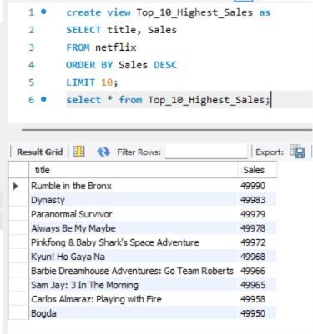

Top 10 Most Viewed Titles
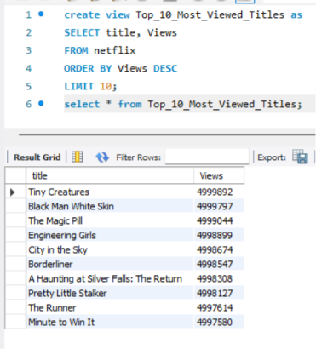

Content by Country
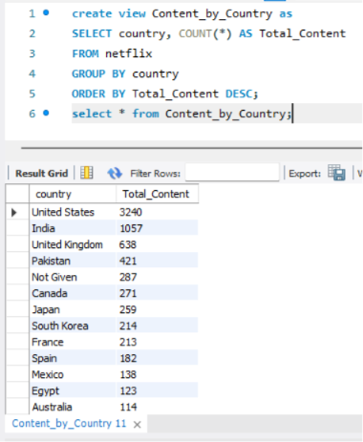

Content by Subscription Type
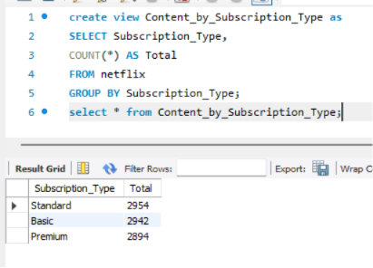

Revenue by Subscription Type
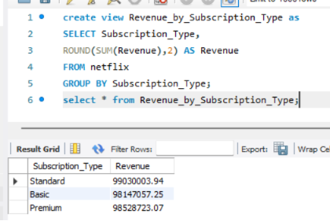

Profit by Region
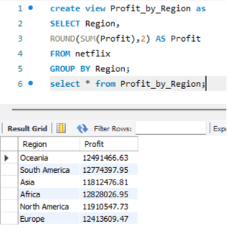

Sales by Region
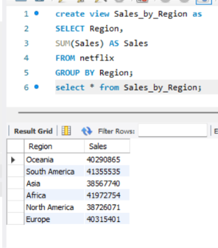

Revenue by Country
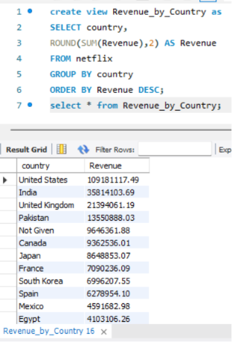

Number of Movies Released Each Year
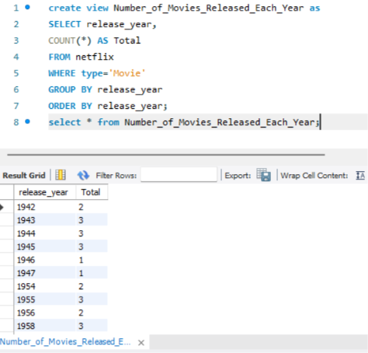

Number of TV Shows Released Each Year
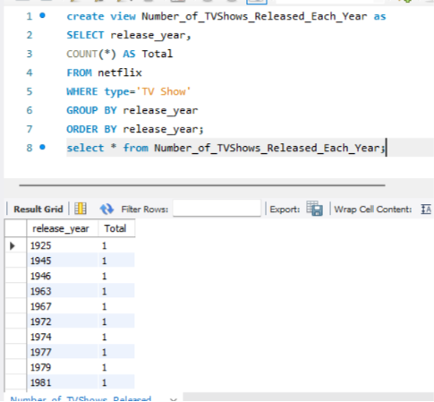

Latest Released Content
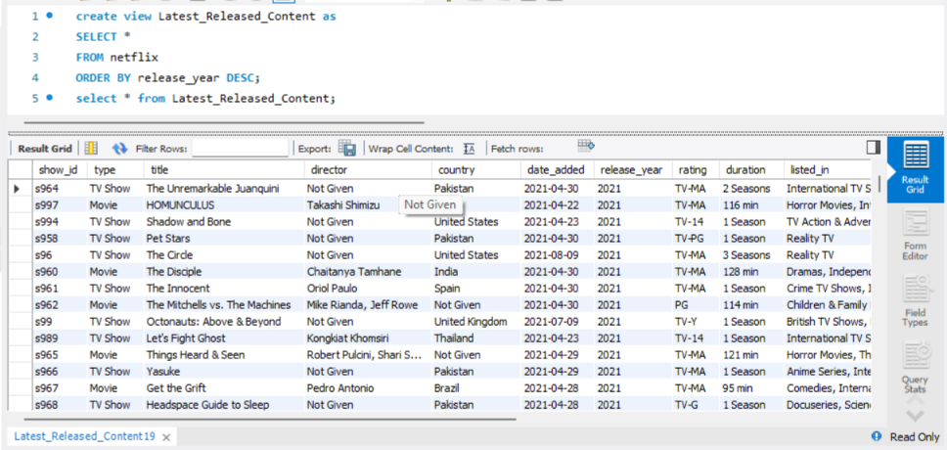

Highest Revenue Country
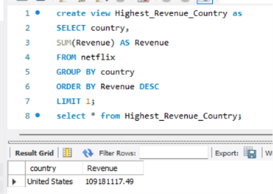

Top 5 Directors
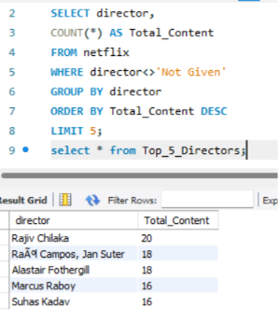

Average Profit by Region
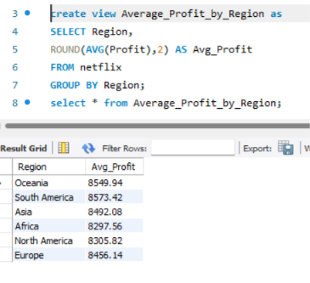

Rating Wise Content
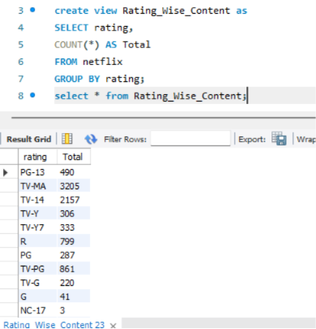

Most Common Genre
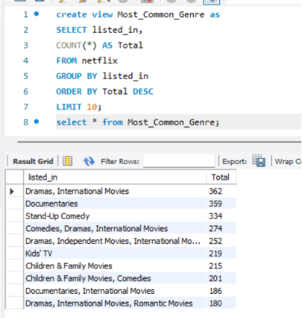

Revenue Greater Than Average
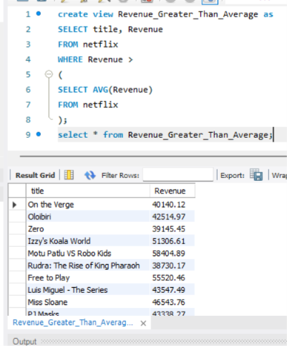

Profit Margin
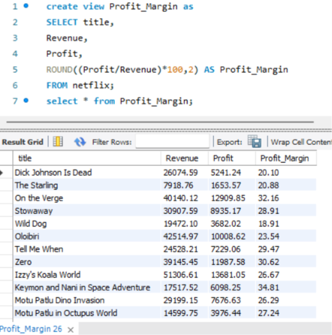

Rank Movies by Revenue (Window Function)
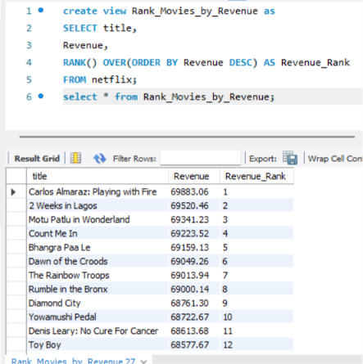

Top Revenue in Each Region
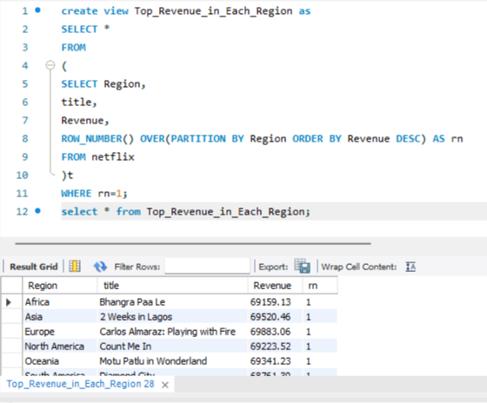

Revenue by Year
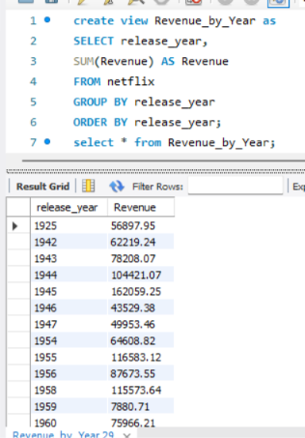

Dashboard KPI Query
